Microsoft Server 2008 R2 Windows Deployment Services
Installation & Configuration

WDS Requirements
- Server joined to an AD Domain
- DHCP
- DNS
- NTFS Formatted Drive to store Images

WDS can be installed on 2003 SP2, but there are more features with Server 2008.
- Multicast
- EFI Network boot support for x64 systems
- Enhanced TFTP performance
And Even more with Server 2008 R2.
- Multicast
  - IPv6
  - Slow Client Handling
- Driver provisioning

  - Provides the ability to deploy driver packages to client computers based on their hardware as part of an installation (the install image must be Windows Vista with SP1, Windows Server 2008, Windows 7 or Windows Server 2008).
  - Provides the ability to add driver packages to boot images (Windows Server 2008 R2 and Windows 7 images only).
- Extensible Firmware Interface (EFI)
  - Supports network booting of x64-based computers with EFI.
  - Includes Auto-add functionality.
  - Includes DHCP referral to direct clients to a specific PXE server.
  - Provides the ability to deploy boot images using multicasting.

Install & Configure WDS

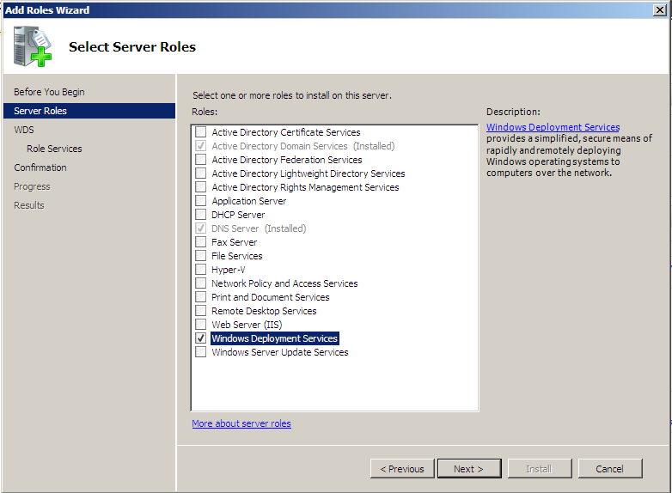
- Add WDS Role and Click Next, Next.

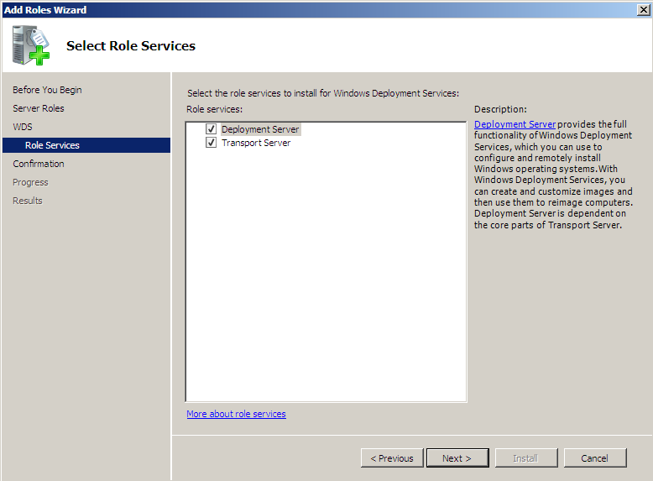
- Make Sure Both Role services Are Checked And Click Next
- Click Install
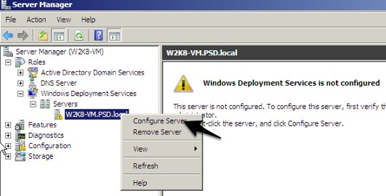
- After the install is done, Expand WDS;Servers, Right Click on the Server and Click on Configure Server Then Click Next (*If you’re not running R2, You might have to close Server Manager MMC and Reopen it to see the server listed.)

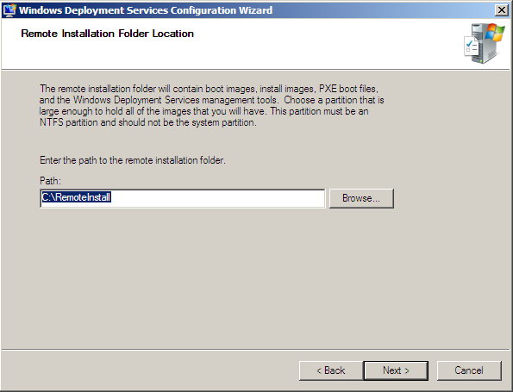

- Choose the path that you want your images saved to. (Drive C:\ is not recommend) Click Next

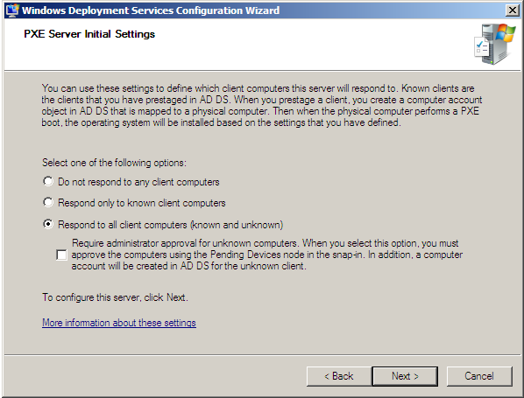
- Click on “Respond to all client computers, and Click Next.

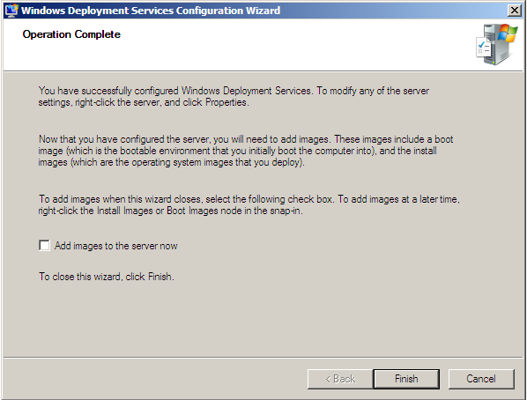
- Uncheck ‘Add images to the Server now’ and Click Finish.

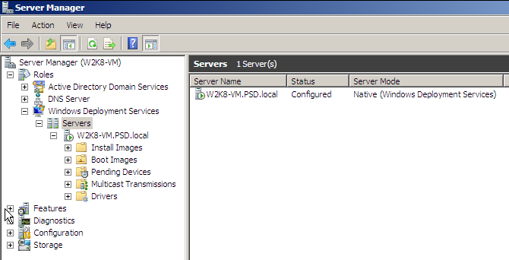

Image Types

There are 4 Different Types of images.
  - Boot Image - WinPE
- Windows Install Environment.
  - Discover Image
- Used For Hardware that does not support PXE boot.
  - Capture Image
- For Creating an Install Image(WIM) From a Reference(Master) Computer. (Sysprep must be ran, or there will not be a drive to capture.)
  - Install Image - OS
- Image captured from a reference computer or install.wim from a Vista/Win7/Srv08 Install DVD

Adding Images
We need to add a Boot Image. You can get this off of a Windows 7/Vista/Server 2008 install DVD. Vista’s boot.wim doesn’t support multicast, It’s recommend to import the latest Windows OS Media for advance feature support and the latest hardware drivers.
Import Boot Image
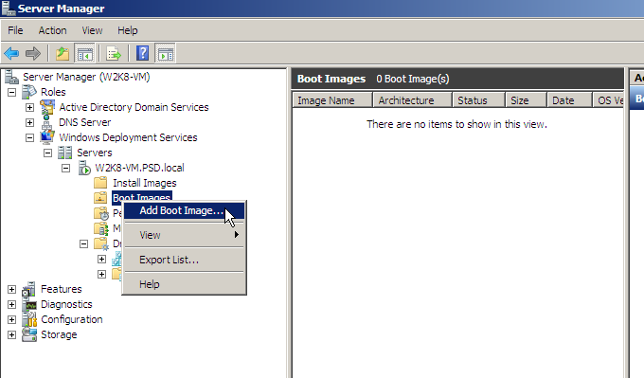
- Open Server Manager and Expend Down to Boot Images Under WDS,
- R-Click on ‘Boot Images’ and Click Add Boot Image.

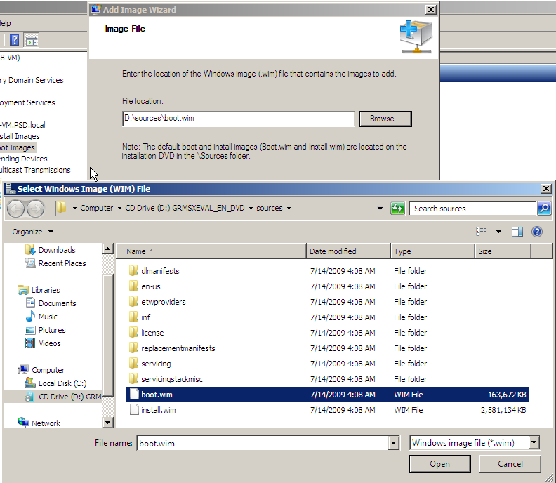
- Click Browse, And browse to the Sources directory on a Vista/Svr08/Win7 Install DVD. Select boot.wim and click Open, Then Click Next.

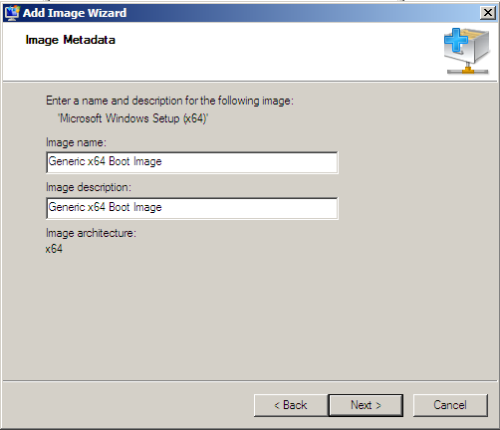
- Name the Image and Click Next
- Click Next

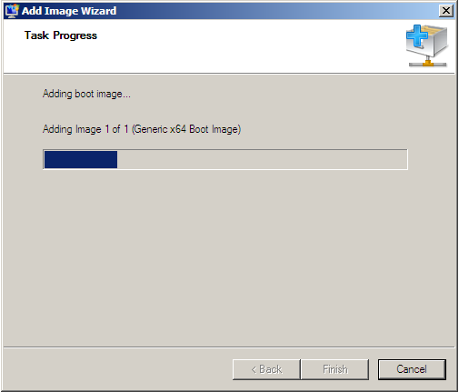
- Now it’s importing the boot image into WDS. This takes about 2-5 Minutes, Click Finish.

Creating Capture Image

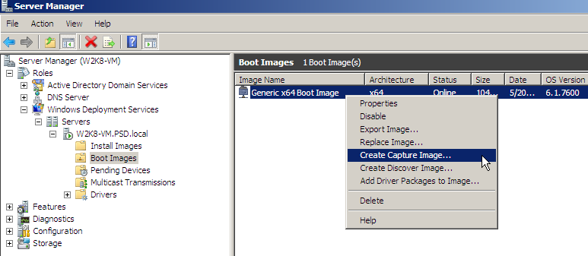
- R-Click on the boot image you just imported and click ‘Create Capture Image’

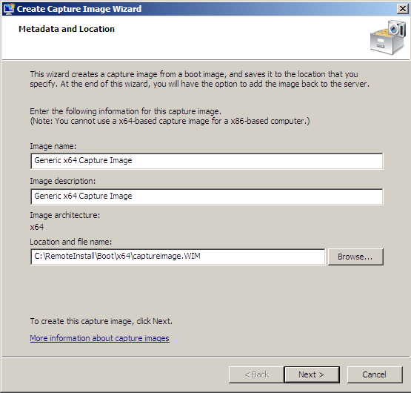
- Rename the image from Boot to Capture Image, Click browse, save it under the Remoteinstall directory, type in a filename and click Open, and Click Next.
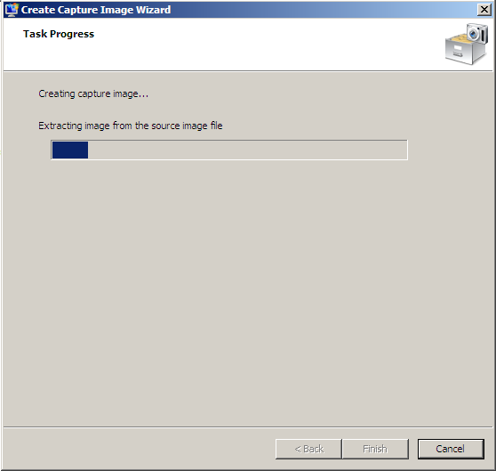
- This takes about 5-10 Minutes,
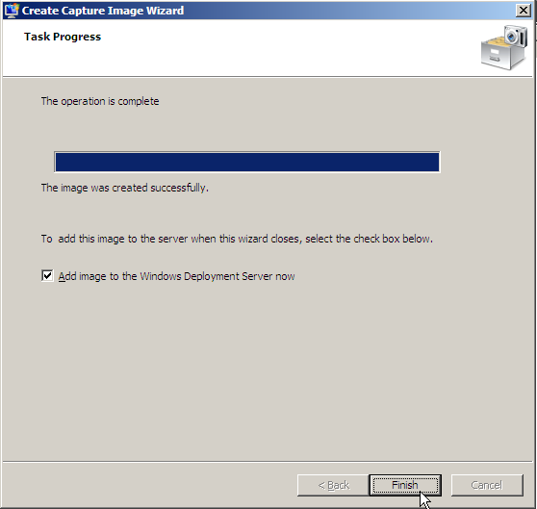
- Check ‘Add image to the WDS Server’ Click Finish

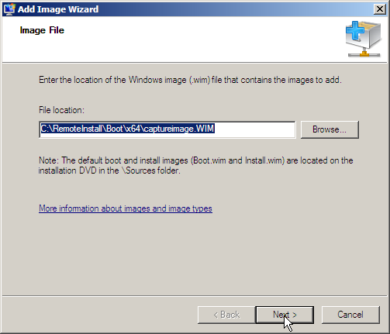
- Click Next
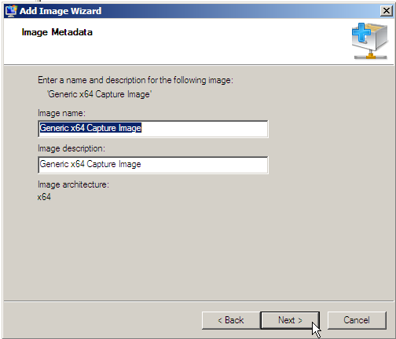
- If the Image looks Good, Click Next
- Click Next

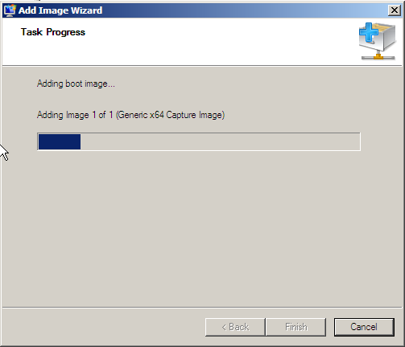
- Now it’s importing the capture image into WDS, Click Finish when it’s Done.

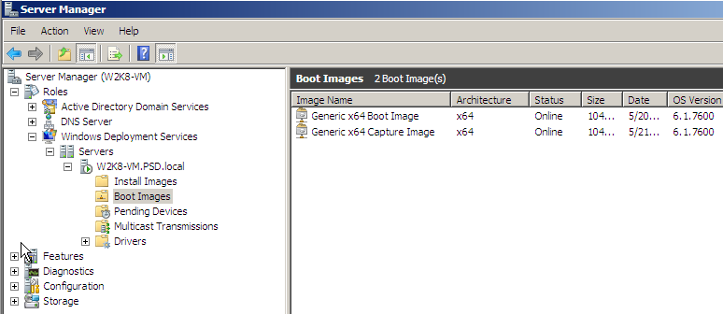
You should now see both a Boot Image and Capture Image listed under the Boot Images node.

Importing Install Images
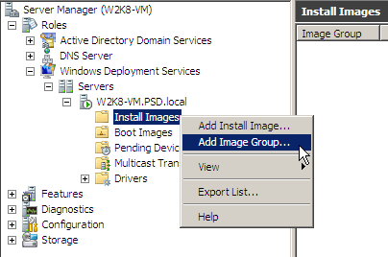
- Create an Image Group. Right Click on Install Images Folder, and Click on Install Group

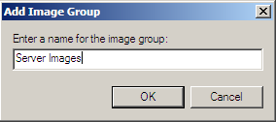
- Name the Image Group and Click Next

Image Security
By Default, Authenticated Users have rights to install images. To fix this We need to set more security on Image Groups.

I’ve added a few more Install Groups to demonstrate this. You can not create a install group inside of another install group.
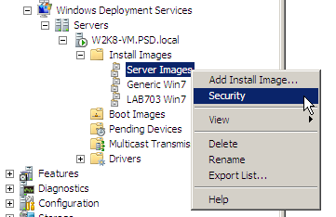
- Right Click on the Install Group and Click Security.

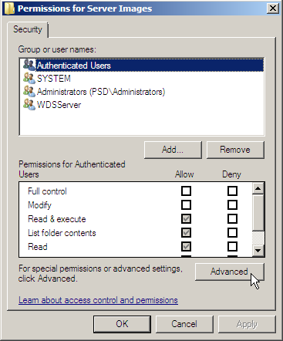
- Click Advance

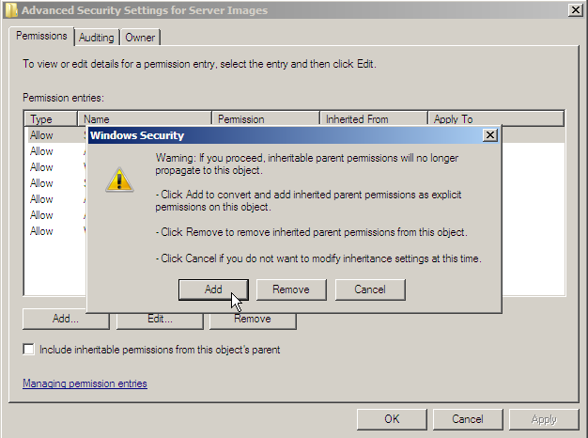
- Uncheck ‘Include inheritable permissions from this object’s parent’. Sometimes you will see ‘Windows Security’ Box Pop Up, If this happens just Click Add and Click OK.

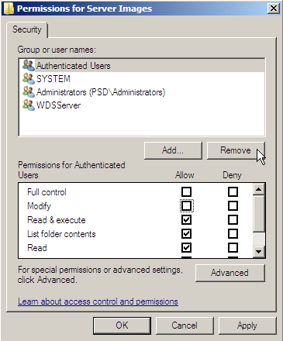
- Select Authenticated Users, and Click Remove, Then Click Apple, And OK.
- Repeat this for the Remaining groups you have.

Add another account.
I’m adding Account I want the computers to be named by.
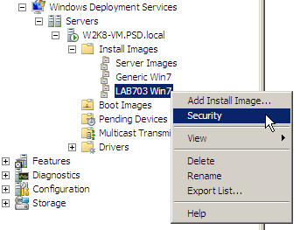
- Right Click the Group you want this to apply to, Click Security
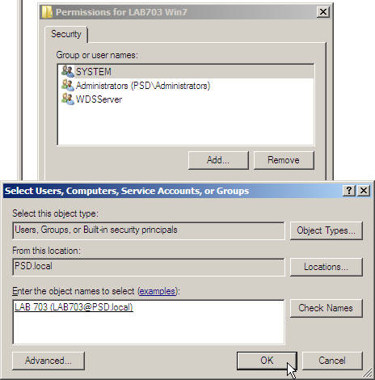
- Click Add, Type in the account you want to use, Click Check Names, and Click OK
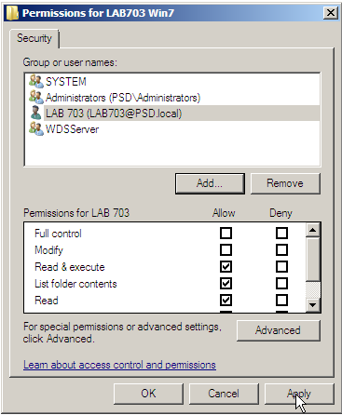
- Click Apply and OK

Import Install Image
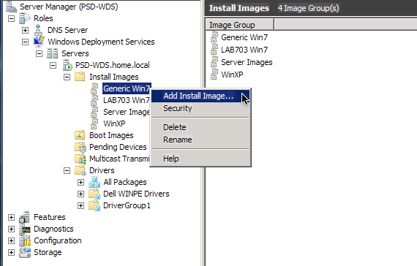
- Right Click on the created Image Group, Click ‘Add Install Image’

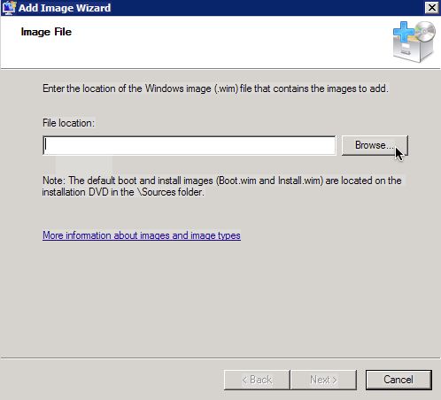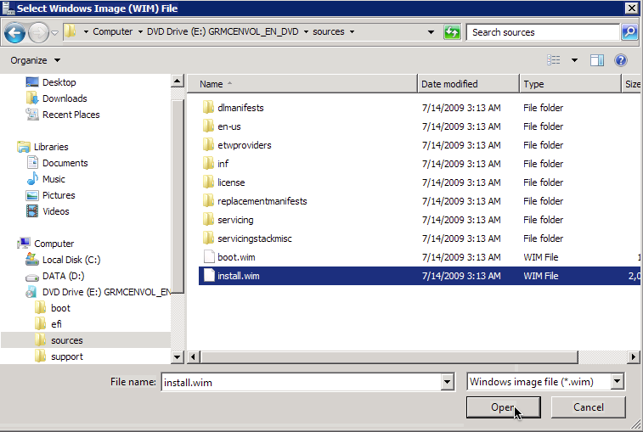
- Click Browse, And Browse to the sources directory on the install DVD. Select install.wim and click Open and Click Next.
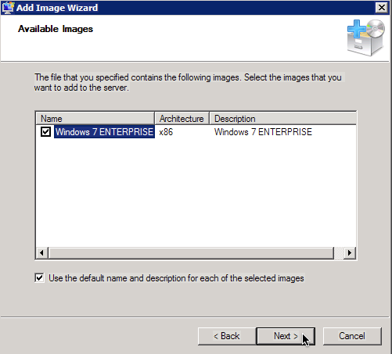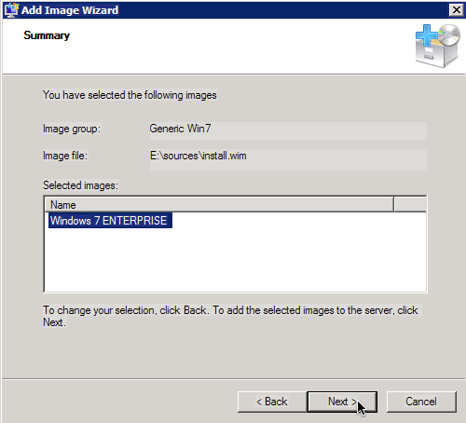
- Click Next 7. Click Next

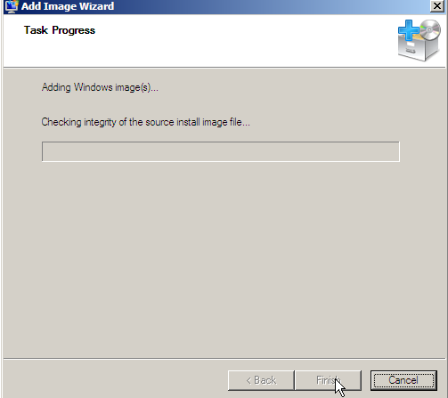
- This starts importing the WIM Install Image into WDS. It takes +20 minutes, Click Finish when it’s done.
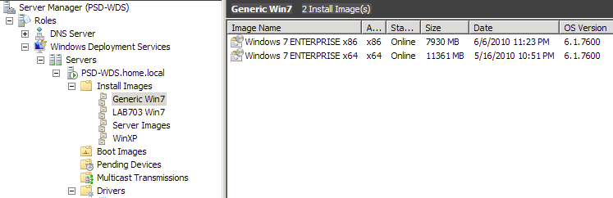
The Image should be listed in the Image Group.

Network Boot
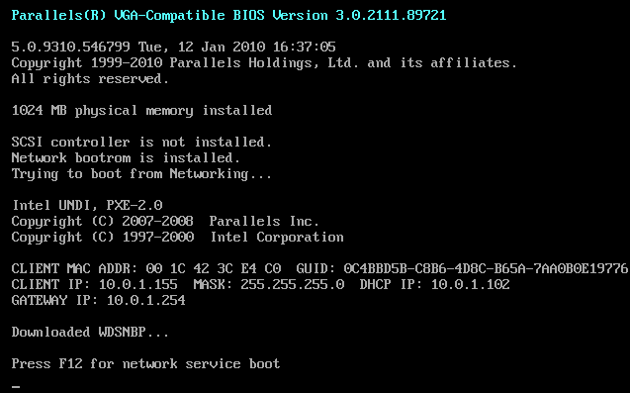
- PXE/Network Boot your computer, when prompted press F12.
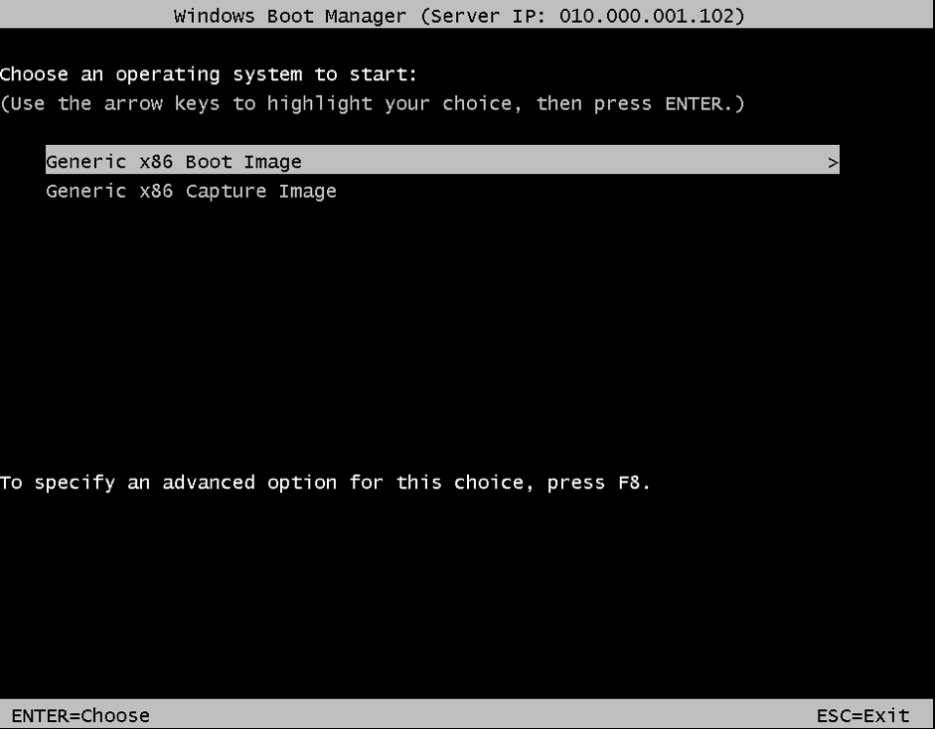
- Press Enter to Choose Generic x86 Boot Image
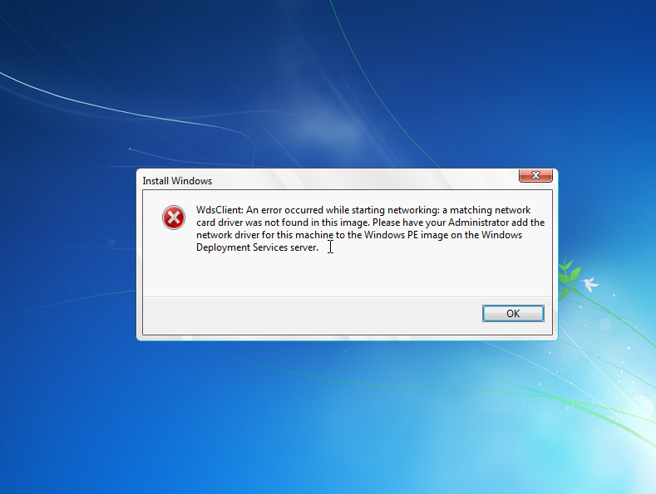
- Need to Add Network Drivers to Boot Image

Inject Drivers With Windows Server 2008 R2

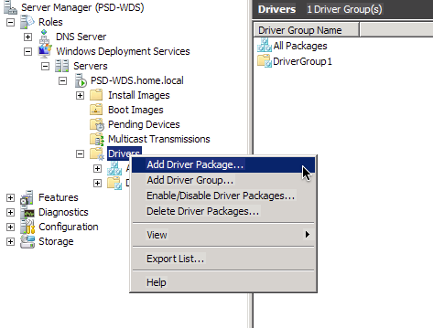
- In Server 2008 R2 you get a Drivers nod, R-Click This and Click ‘Add Driver Package’
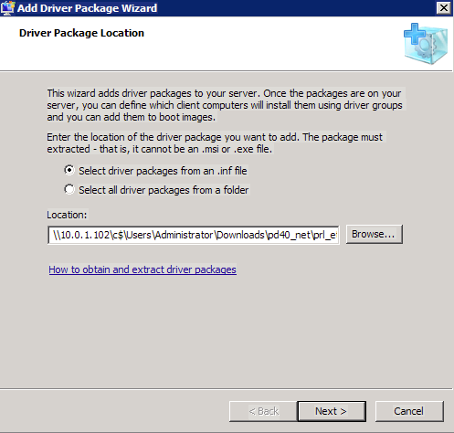
- Click Browse, Browse to the folder that has the proper driver for the network card.
Click Next
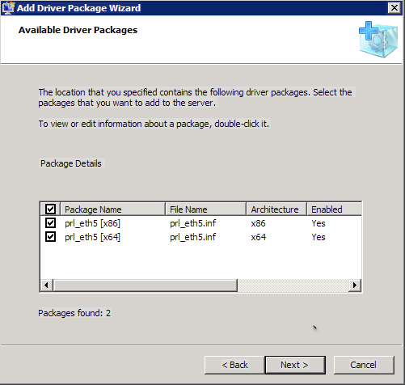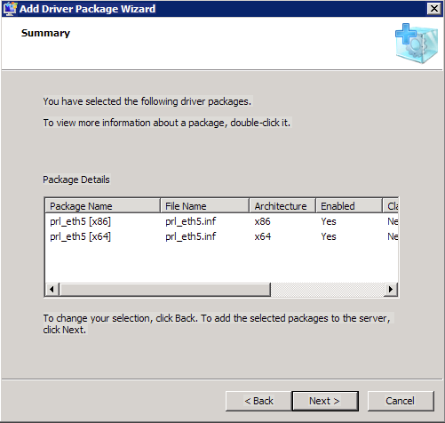
- Check the Driver you need and Click Next. and Next On Summary Screen.
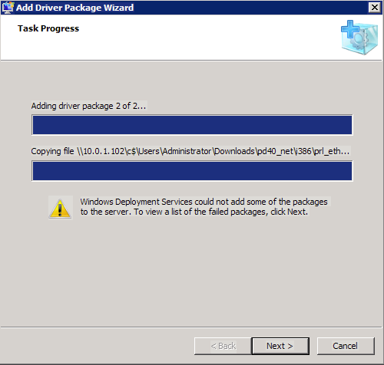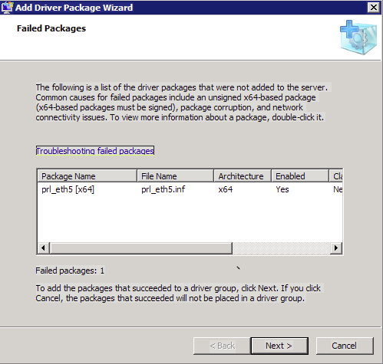
- If you only have x86 images imported you will get this error, or in my case the x64 driver isn’t signed. Click Next. If you get this error, Click Next again

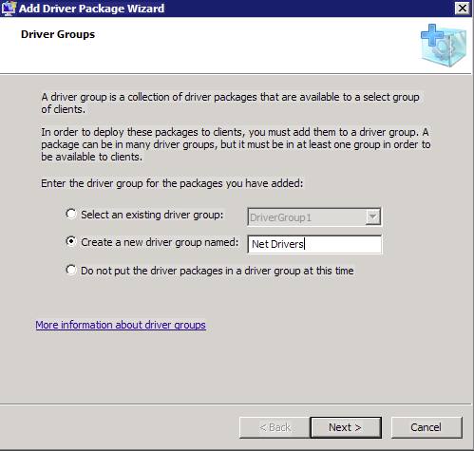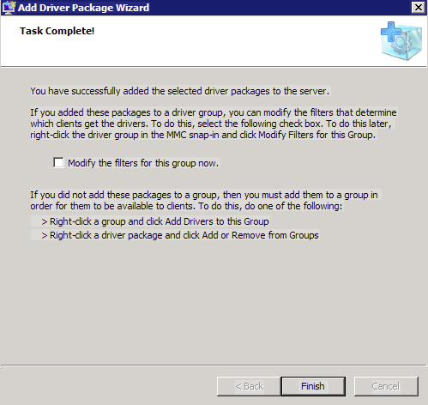
- Select a Driver Group or Create a new one and Click Next and Uncheck the Modify Box and Click Finish.
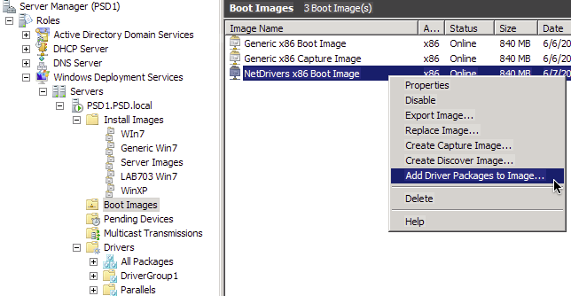
- Unless you want to apply these Drivers to the Generic Boot Image, Import it again and name it something different. R-Click the boot image and Click ‘Add Driver Packages to Image’

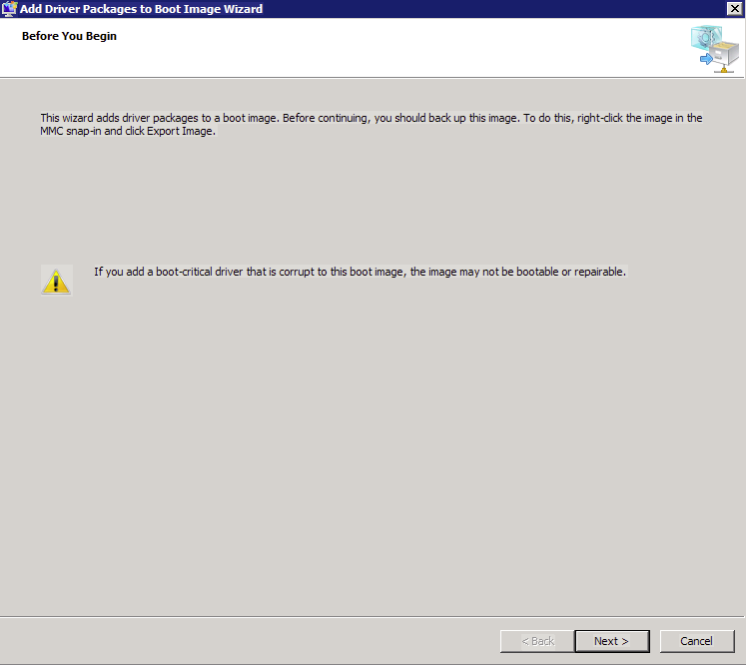
- Click Next

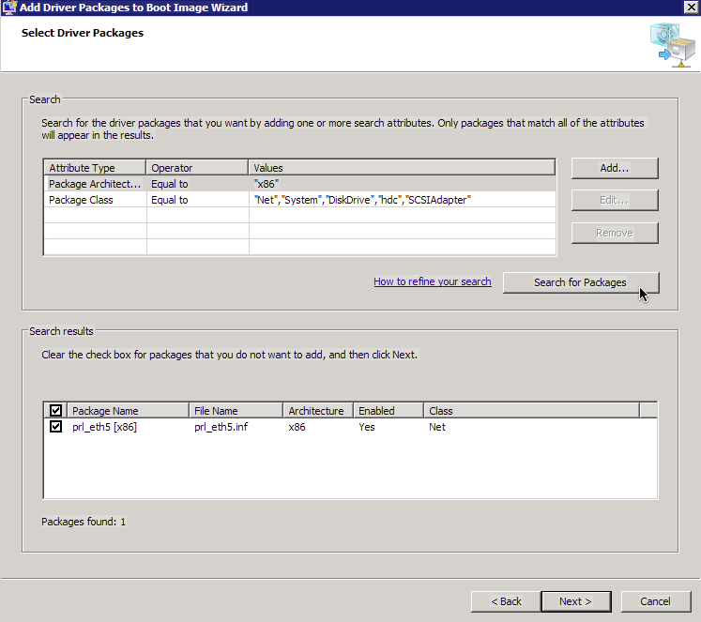
- Click ‘Search for Packages’ and Click Next.
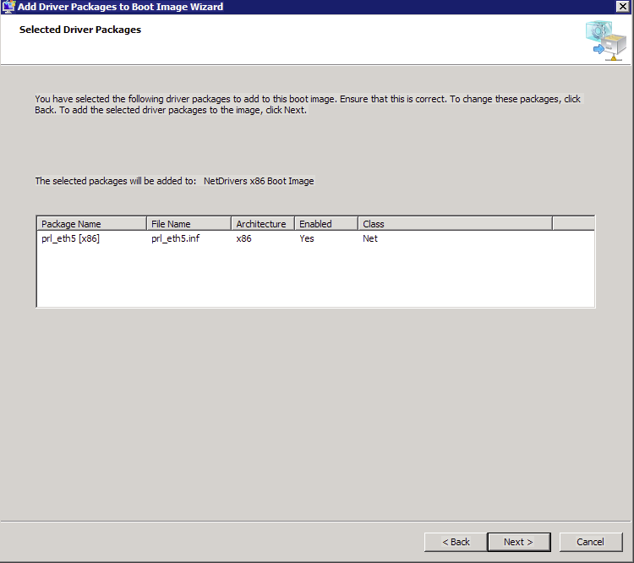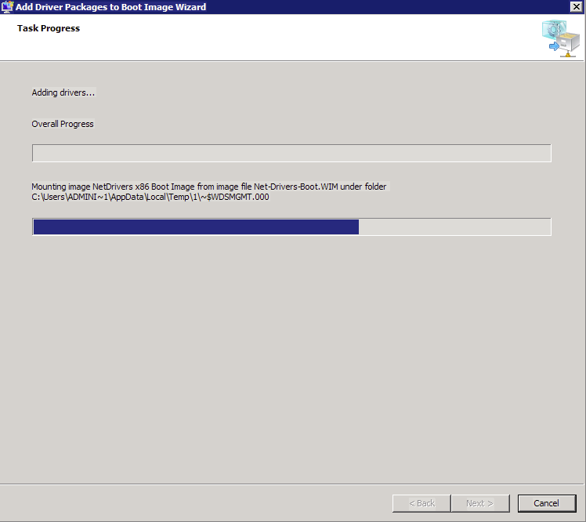
- Click Next and Click Finish when done.

For Server 2008 and Server 2003 you have to add the drivers with the command line.

Using dism.exe to inject drivers into a Windows 7 Boot Image.
- Download and install WAIK 3.0 (Windows Automated Installation Kit), Also download the drivers needed for your hardware and put them in a folder on c:\. I put the one I need in C:\NetDrivers
- Extract the boot.wim from WDS or copy it from an Windows 7 Install DVD to C:\
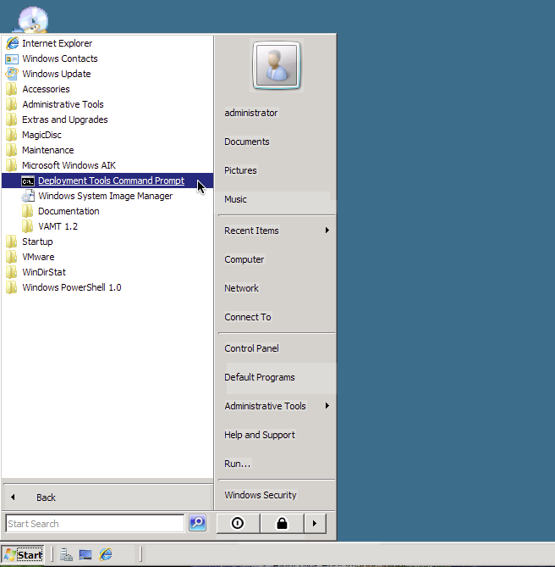
- Click Start and Open WAIK ‘Deplyment Tools Command Prompt’
- Type ‘mkdir c:\img’ to create a folder to mount the image to.
- Type ‘dism /mount-wim /wimfile:”c:\boot.wim” /index:1 /mountdir:”C:\img”
Note: /index:1 is mounting the First image inside of the .wim
- Type ‘dism /image:”c:\img” /add-driver /driver:”c:\netdrivers\prl_eth5.inf
Note: If you get error 50, try it with /forceunsigned
- Type ‘dism /unmount-wim /Mountdir:”c:\img” /commit
Note: This writes the changes to the image and unmounts it from c:\img
- You can now import this image into WDS and should be able to boot from it.

Using peimg to inject drivers into a Vista Boot Image.
- Download and install WAIK 2.0 (Windows Automated Installation Kit) and The Drivers needed for your hardware and put them in a folder on c:\. I put the one I need in C:\NetDrivers
- Extract the boot.wim from WDS or copy it from an Windows Vista Install DVD to C:\
- Click Start and Open WAIK ‘Deployment Tools Command Prompt’
- Type ‘mkdir c:\img’ to create a folder to mount the image to.
- Type ‘imagex /mountrw c:\boot.wim 2 c:\img
Note: This mounts index 2 image in read write mode to c:\img
- Type ‘peimg /inf=c:\netdrivers\prl_eth5.inf /image=c:\img’
- Type ‘imagex /unmount /commit c:\img’
Note: This Writes the changes to the image and unmounts it from c:\img
- You can now import this image into WDS and should be able to boot from it.

Fresh install of Windows 7 deployed from WDS

Network(PXE) Boot the computer and Press F12 when Prompted

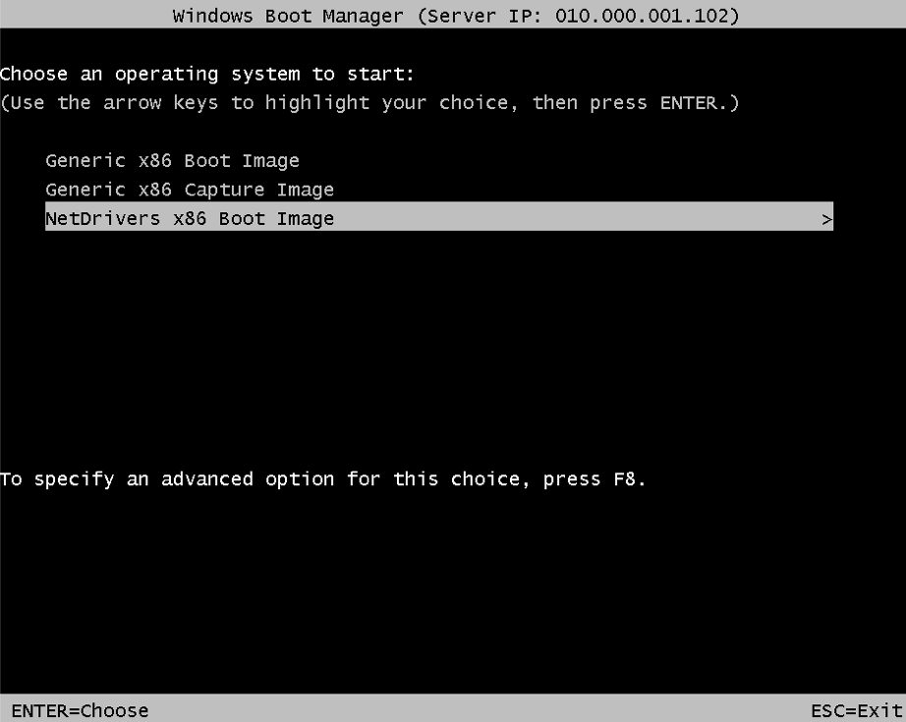
- Arrow Down to the Boot you applied the driver to and Press Enter.
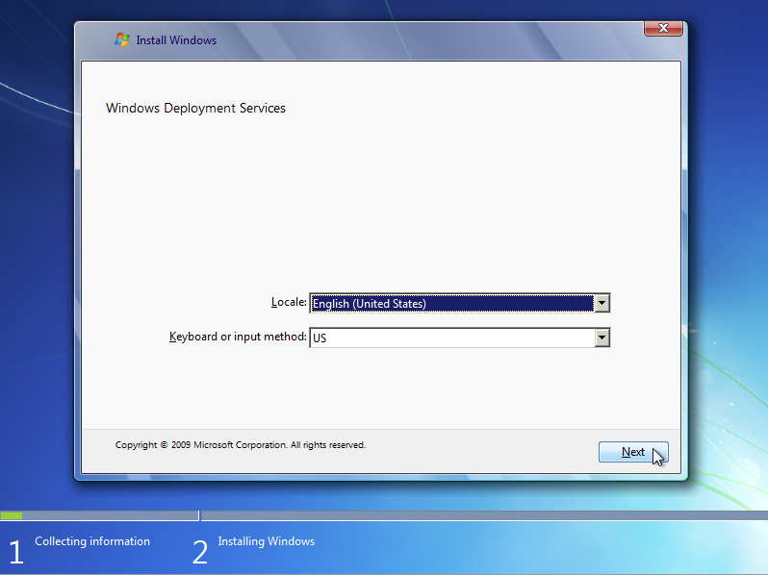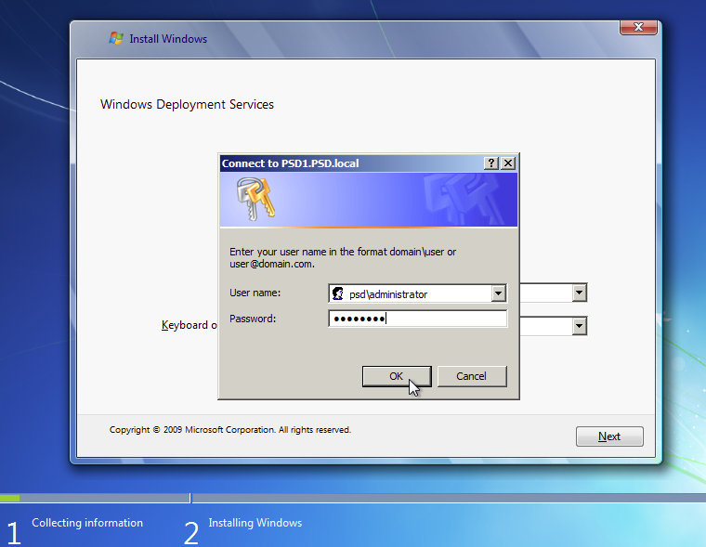
- Click Next and type in your domain\username and password. Click OK
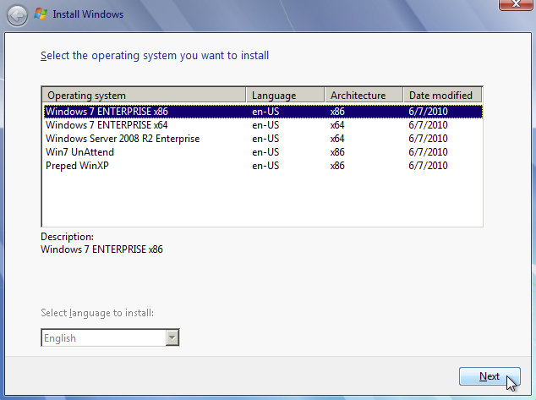
- Select an Image you want to deploy and Click Next

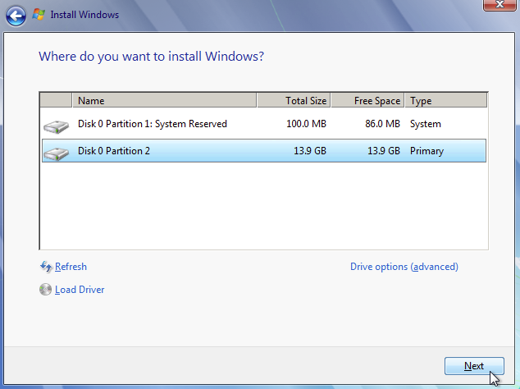
- Select a Partition that you want to install to and Click Next.
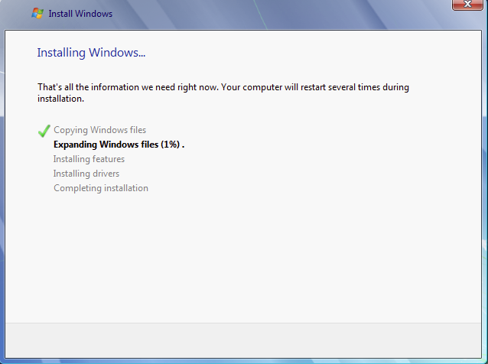
This Takes around 20-25 minutes.

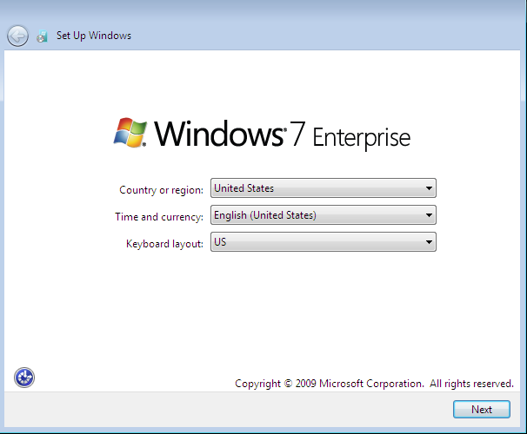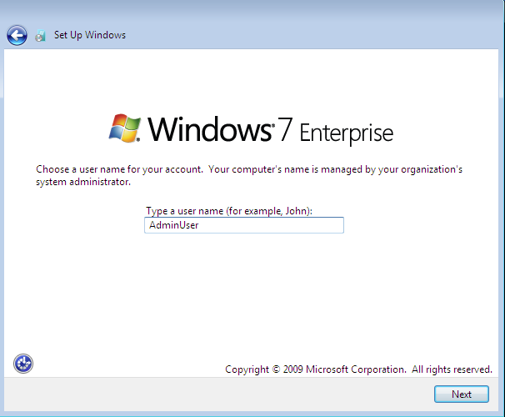
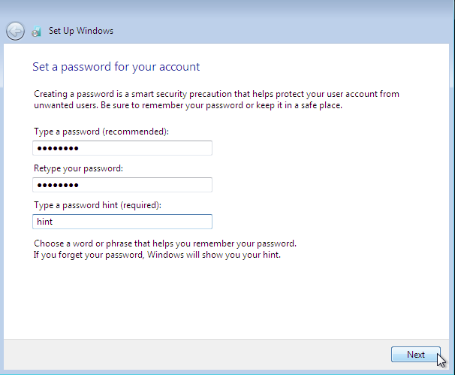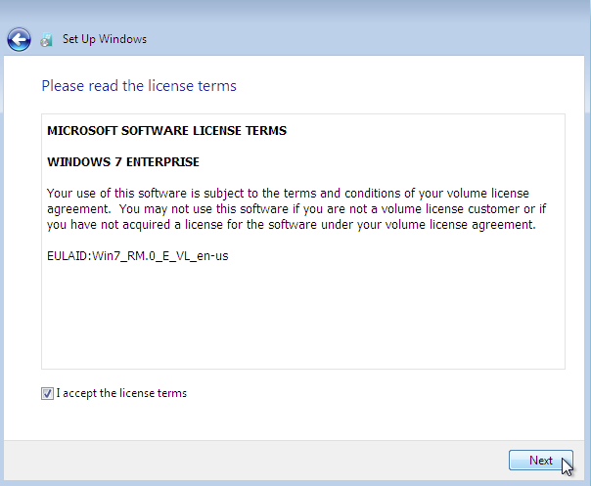
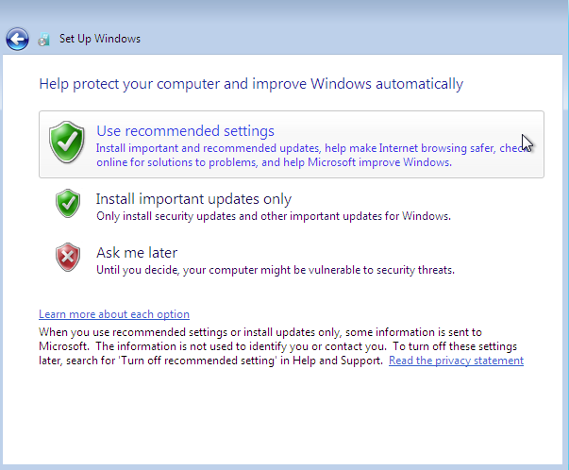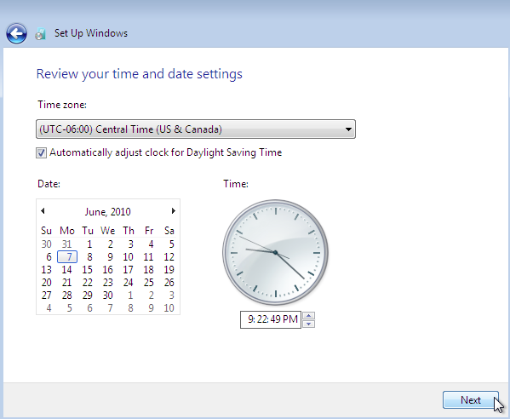

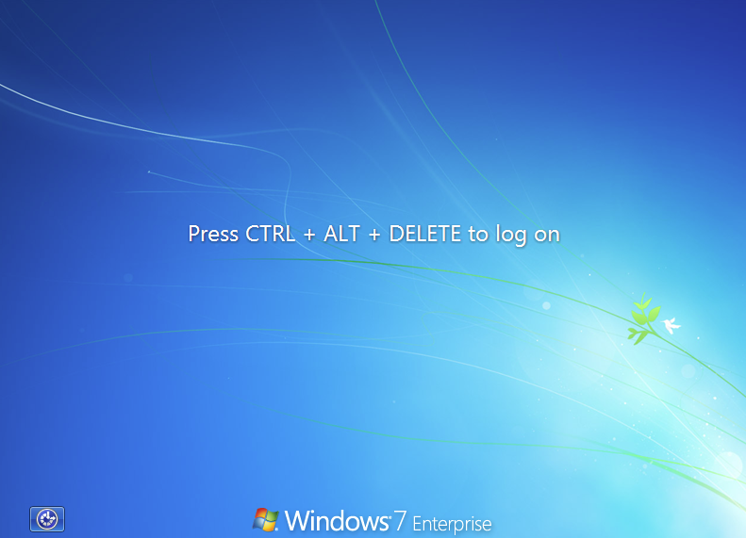
After 10+ Clicks you have a freshly Installed Windows 7 Domain Joined Computer.

Capturing an Image from an reference(master) computer with Windows Vista/7.
- Always Document what you need to do, and what you actually did. It never fails you will forget to do something and when you go back to do what you missed and for get something else. It’s nice to have a check list to go by. Here’s a few things to start the check list.
  - Install Windows Updates and Programs
  - Turn off System Protection(Restore)
  - Delete downloaded updates in \windows\SoftwareDistribution\Download\*
  - Delete Files in %TEMP%\*
  - If using AVG. Download and Run AVG Clone Tool.

- Before sysprep, Disjoin computer from domain (if joined).
- From a Command Prompt Windows Type ‘cd c:\windows\system32\sysprep’
- Now Run sysprep with this command ‘sysprep /oobe /generizel /shutdown
- Sysprep will shutdown the computer when it’s done. Turn the computer back on and Network (PXE) Boot the computer. (It’s very important that after you sysprep the computer it does not boot the OS, if you miss the network boot and the computer starts to boot the OS just let it boot and run sysprep again. IF you hit CTRL ALT DEL, it may or may not work.)

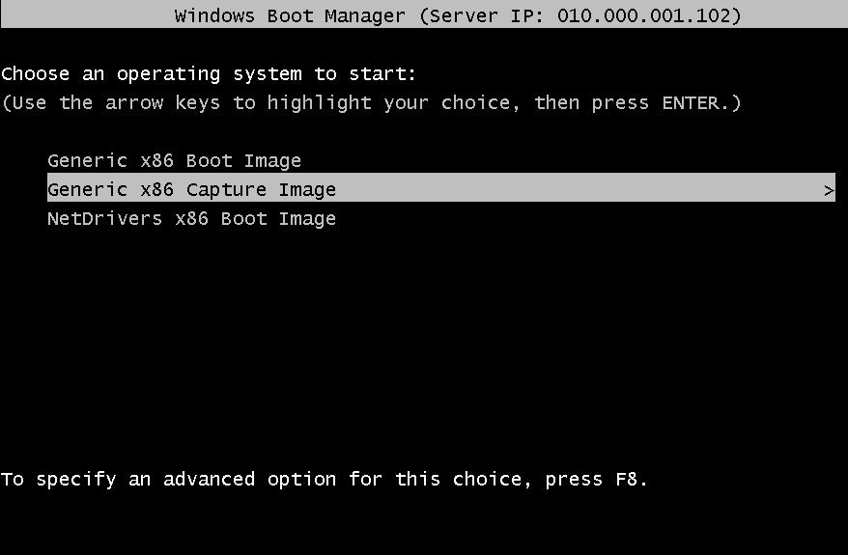
- This time arrow down and select the Capture Image. If you have added drivers to the boot image you will need to recreate the capture image from that boot image.
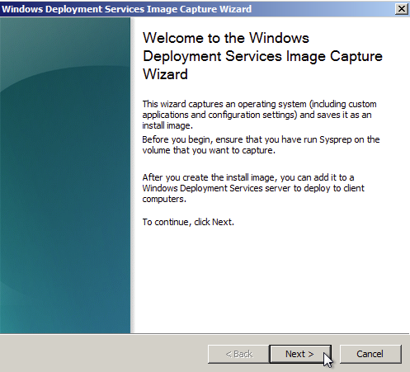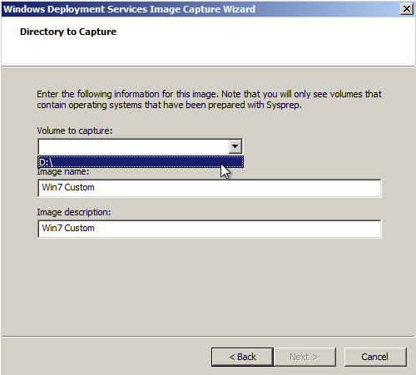
- Click Next. Now Select a Volume to Capture, in this case it’s D:\. This letter just depends on how the drive is formatted. If you do not have any to choose from, It could mean one of two things. You didn’t sysprep Or You need to inject drivers into the boot image for the SATA controller.

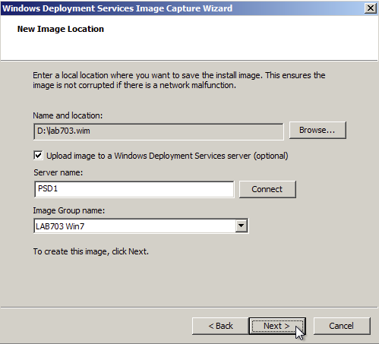
- Click Browse, and browse to the root of the drive that you are capturing, OR can plug in a flash drive/external hard drive and Click Save. Check the checkbox to upload it to the WDS Server. Type in the name of the WDS server and Click Connect. Type in domain\username and password. Select an Image Group to associate the image with. Click Next.
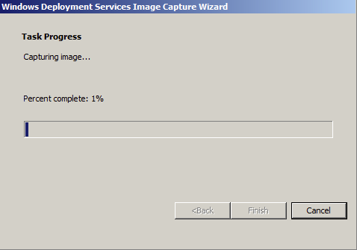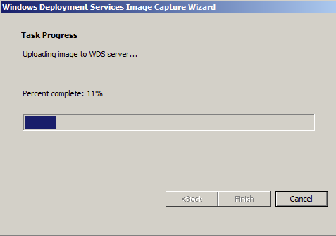
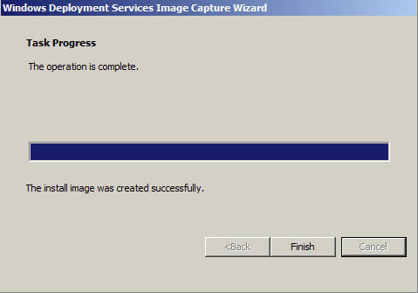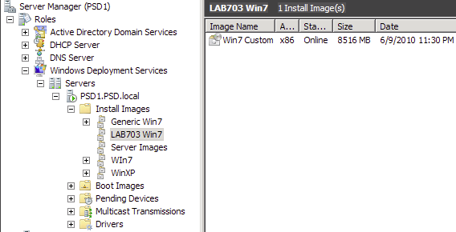
- Click Finish

Fully Unattended Install of Windows 7

For WDS you need 2 Answer Files. 1 for WinPE and the Other for the image.

WinPE Answer File
- Download and Install WAIK 3.0
- Open Windows System Image Manager
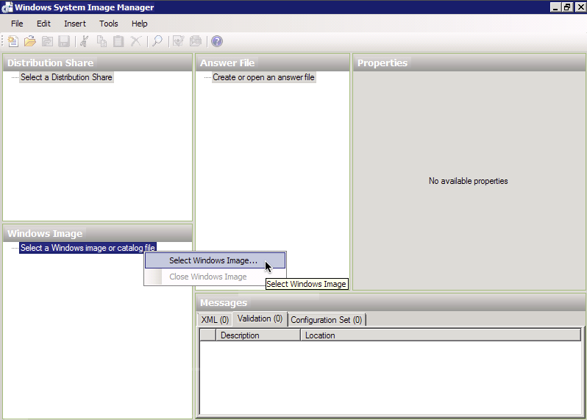
- Once WSIM is Open, R-Click on ‘Select a Windows Image’ and Click Select Windows Image
- Browse for an the install image you plan to use the unattended file for. I’m using a Windows 7 install.wim.

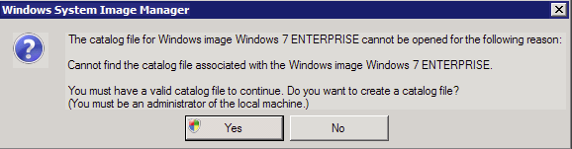
- Click Yes
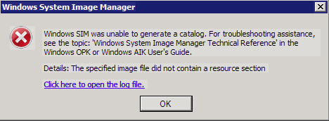
You will receive an error like this one if you try to use an x86 image and have installed WAIK x64 bit or in this case, try to open an image imported into WDS in \RemoteInstall\Images\ you must export the image from WDS to use it.

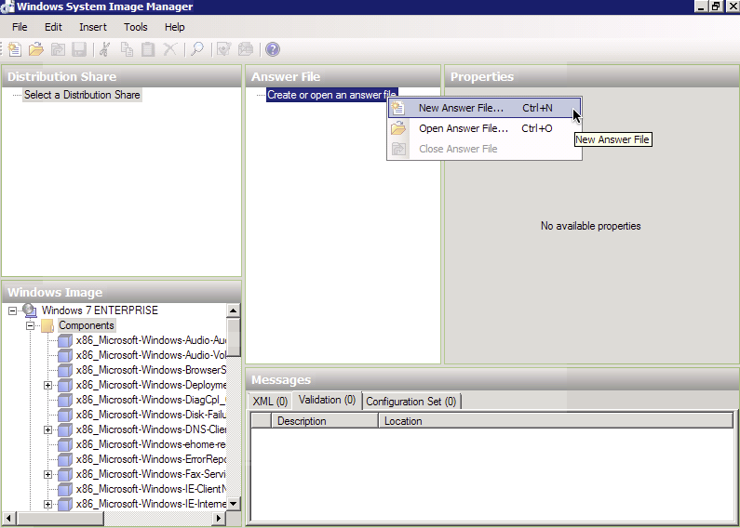
- R-Click on ‘Create or Open Answer File’

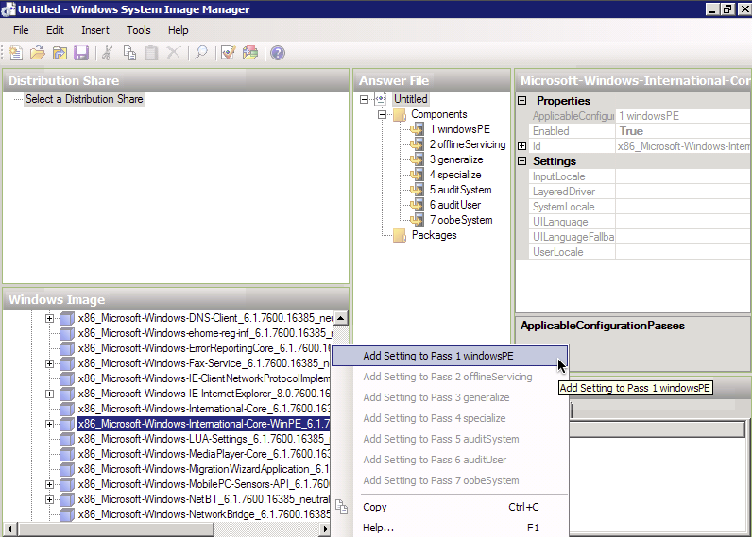
- In Windows Image pane Find and Add the following items by R-Clicking the item and adding it to the correct pass.
  - x86_Microsoft-Windows-International-Core-WinPE... > pass 1 windowsPE
  - Expand x86_Microsoft-Windows-Setup...
    - DiskConfiguration;Disk;CreatePartition > pass 1 windowsPE
    - DiskConfiguration;Disk;ModifyPartitions > pass1 windowsPE
    - WindowsDeploymentServices;ImageSelection;InstallTo > pass 1 windowsPE
    - WindowsDeploymentServices;Login;Credentials > pass 1 windowsPE

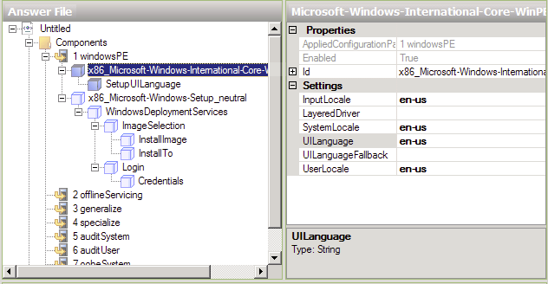
- Now that the items have be added to the answer file, click on each item and set it’s properties in the right hand pane from the information below.
  - x86_Microsoft-Windows-International-Core...
    - InputLocale=en-us
    - SystemLocale=en-us
    - UILanguage=en-us
    - UserLocale=en-us
    - Click SetupUILanguage
      - UILanguage=en-us
  - x86_Microsoft-Windows-Setup...
    - DiskConfiguration;Disk
      - Action=Modify
      - DiskID=0
      - WillWipeDisk=true
      - R-Click on CreatePartitions and Click Insert New..
        - Action=AddListItem
        - Extend=true
        - Order=1
        - Type=Primary
      - R-Click on ModifyPartitions and Click Insert New..
        - Action=AddListItem
        - Active=true
        - Format=NTFS
        - Label=OS-Disk
        - Letter=C
        - Order=1
        - PartitionID=1
    - WindowsDeploymentServices
      - ImageSelection;InstallTo
        - DiskID=0
        - PartitionID=1
      - Login;Credentials
(Use this if you want to automaticaly login after pressing F12)
        - Domain=YourDomain
        - Password=YourPassWord (stored in plan text)
        - Username=YourUsername
- Click File and Save; Name this unattend.xml. This file must be placed in
\RemoteInstall\WdsClientUnattend Folder
- To set the server to use this file Open up Server Manager; R-Click the WDS Server and Click Properties
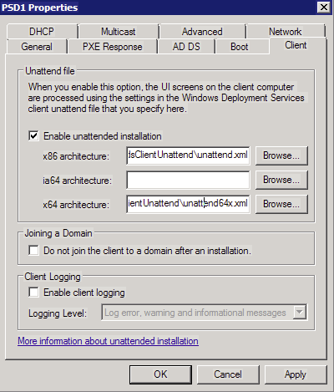
- Click the Client TAB and Check ‘Enable unattended installation’; Click Browse on the x86 architecture and Select the file in wdsClientUnattend Folder and Click Open.
Note:If You have an x64 bit boot image you will need to create an x64bit answer file for it.
- Click OK

Install Image Answer File
- Repeat Steps 1-6 above
- In Windows Image pane Find and Add the following items by R-Clicking the item and adding it to the correct pass.
  - x86_Microsoft-Windows-Security-SPP-UX > pass 4 specialize
  - x86_Microsoft-Windows-Shell-Setup > pass 4 specialize
  - x86_Microsoft-Windows-UnattendedJoin;Identification > pass 4 specialize
  - x86_Microsoft-Windows-International-Core > pass 7 oobeSystem
  - x86_Microsoft-Windows-Shell-Setup...
    - OOBE > pass 7 oobeSystem
    - UserAccounts;LocalAccounts > pass 7 oobeSystem
- Now that the items have be added to the answer file, click on each item and set it’s properties in the right hand pane from the information below.
  - x86_Microsoft-Windows-Security-SPP-UX
    - SkipAutoActivation=true
  - x86_Microsoft-Windows-Shell-Setup
    - ComputerName=%MACHINENAME%
Note:If you leave this blank it Will ask you in the Setup.
    - CopyProfile=true
Use this if this is a captured image and you set administrator users profile settings. This will copy them settings to DefaultUser Profile.
    - RegisteredOrganization=YourOrg
    - RegisteredOwner=YourOwnerInfo
    - TimeZone=Central Standard Time
  - x86_Microsoft-Windows-UnattendJoin;Identification
    - UnsecureJoin=true
Note:If this is not set it will not join the domain.
  - x86_Microsoft-Windows-International-Core
    - InputLocale=en-us
    - SystemLocale=en-us
    - UILanguage=en-us
    - UserLocale=en-us
  - x86_Microsoft-Windows-Shell-Setup
    - OOBE
      - HideEULAPage=true
      - NetworkLocation=Work
      - ProtectYourPC=3
    - UserAccounts;LocalAccounts; R-Click and click ‘Insert New LocalAccount’
      - LocalAccount
        - Action=AddListItem
        - Description=AdminUser
        - DisplayName=AdminUser
        - Group=Administrators
        - Name=AdminUser
        - Password
          - Value=YourPassWord
Note(This is NOT saved in plane Text)
- Click File;Save Save this as ImageAnswerFile.xml This file dosn’t have to be in a special Directory
- Open Up Server Manager and In WDS role in the Install Images Node, R-Click an Install image you want to run Unattended and click properties.
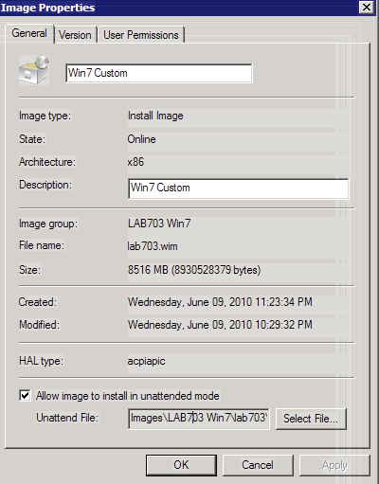
- At the bottom of Install Image properties pane Check ‘Allow Image to install in unattended mode’ Click Select File. browse for the file you just saved and click Open; Click OK
Server 2008 WDS Properties TABS
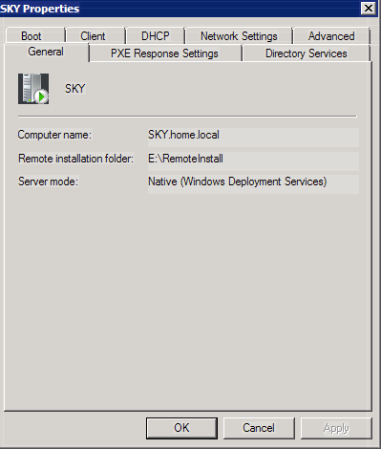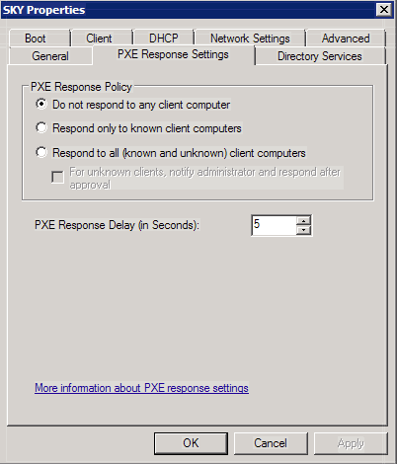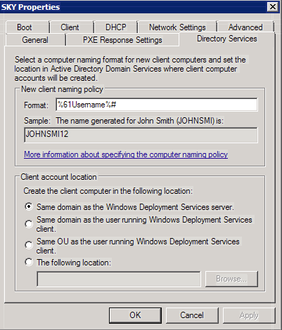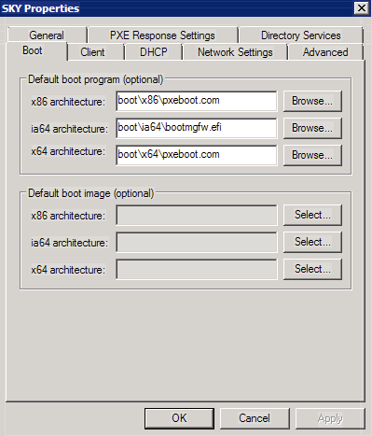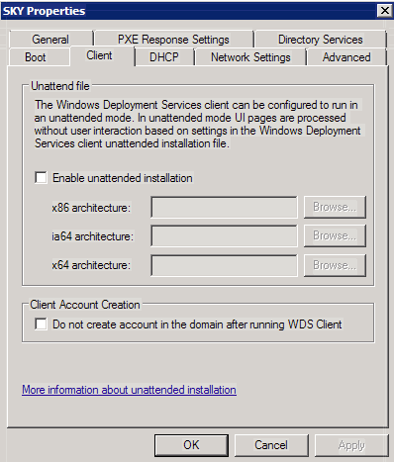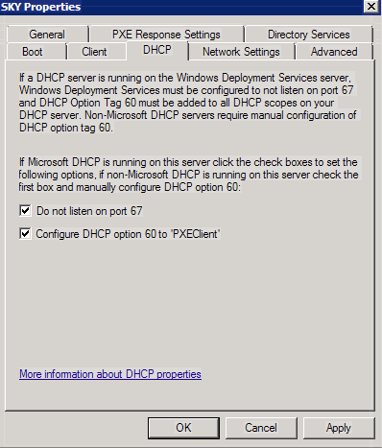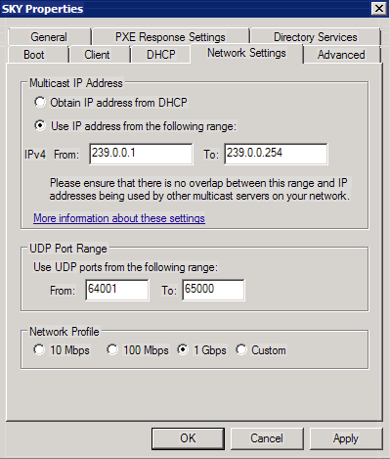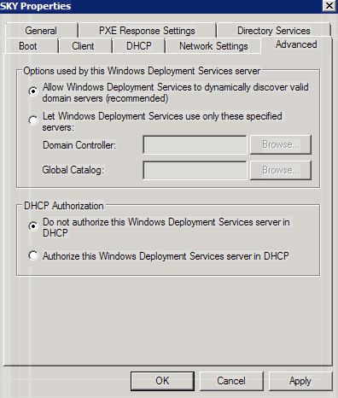

Server 2008 R2 WDS Properties TABS

